DIFFERENT KIT FOR EACH HOUSE: THINK DIFFERENT!

WKE WORLD KEY ENERGY enriches its offer with FAMILY SOLAR, a preconfigured solution, innovative and complete, for the residential market, ready to energy.

WKE World Key Energy produces PV modules showing a market competitive edge in the ample range of Innovative product and In the capability to produce on demand of local and market client.
The experience gained in the field of photovoltaic and the continuous research make it possible to obtain high quality products, for specific needs such as those of the consumer and the family.
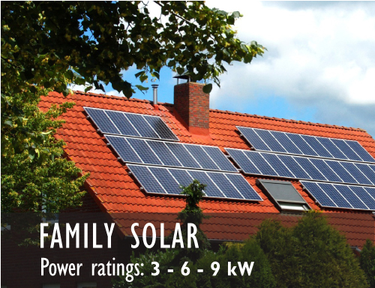
One of the best example of this activity is the Family Solar solution, specifically studied for residential plant and extremely easy to install. These products are exclusively made for Romanian distributors needs.

Family Solar is the complete solution designed by World Key Energy to the small residential photovoltaic system. It is full with all necessary components for the right assembly of the system, consisting of modules, inverters and mounting structures.
It is designed for installers and homeowners.

Family Solar are available in 3 different versions: 3 kW, 6 kW and 9kW.
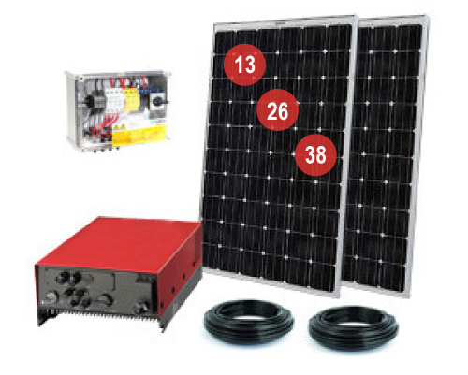
Designed to assist in the selection and implementation of small photovoltaic systems for residential, Family Solar is a solution easy mounting, structured with all the components necessary for the proper functioning of the system:
- Panels (13, 26 or 38)
- String board – complete with surge arresters, diode strings, fuse box;
- Interface boards for the power grid;
- Inverter
- Connecting cables (cc side – ca side)
- Support structures
- Assembly instructions in Romanian

On www.worldkeyenergy.com, thank to an innovative configurator, it is possible to calculate the power consumption of home and discover the ideal kit for the specific need.

For more information, visit www.worldkeyenergy.com.

Press Office in Italy
Valentina Rea
Mob. +39 345 7493067
valentina.rea@wke-mp.com

