SOLAR BATTERY: OFF GRID STORAGE SOLUTION

Off grid photovoltaic systems are highly reliable, effective means of providing power without the regular costs associated with electric utilities and generator power.

Distributed Energy Storage System (DESS) is a new energy power solution that can be used grid interactive and stand alone. An integrated ultra-fast AC transfer switch guarantees that even sensitive back-up loads, like computers, never know when a utility outage occurs. The bi-directional inverter can provide high quality true sine waveform power for the load. And the working mode of the Solar Battery can be selected and adjusted to meet different requirements.
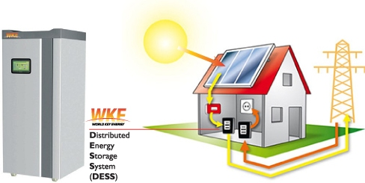
Characteristics:
- On grid and off grid application available;
- Excellent power management function, providing unattended power supply solution;
- Easy installation and maintenance;
- Functioning as UPS to guarantee uninterrupted power supply to the users;
- High security, stability and reliability.

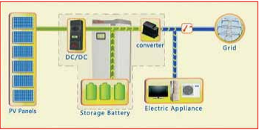
Applications:
- Communication base station;
- Residential application;
- Small commercial or industrial area;
- Areas with electricity price difference between peak period and off peak period, abundant sunshine, unreliable grid or government incentives, etc.

WKE WORLD KEY ENERGY implements off grid PV systems tailored to the specifications of your home. PV system will utilize the newest and the most efficient off grid integration techniques to provide continuous power to any and all home appliances.



For more information, visit www.worldkeyenergy.com.

Press Office in Italy
Valentina Rea
Mob. +39 345 7493067 valentina.rea@wke-mp.com

